HWK 2 VBA Screenshots

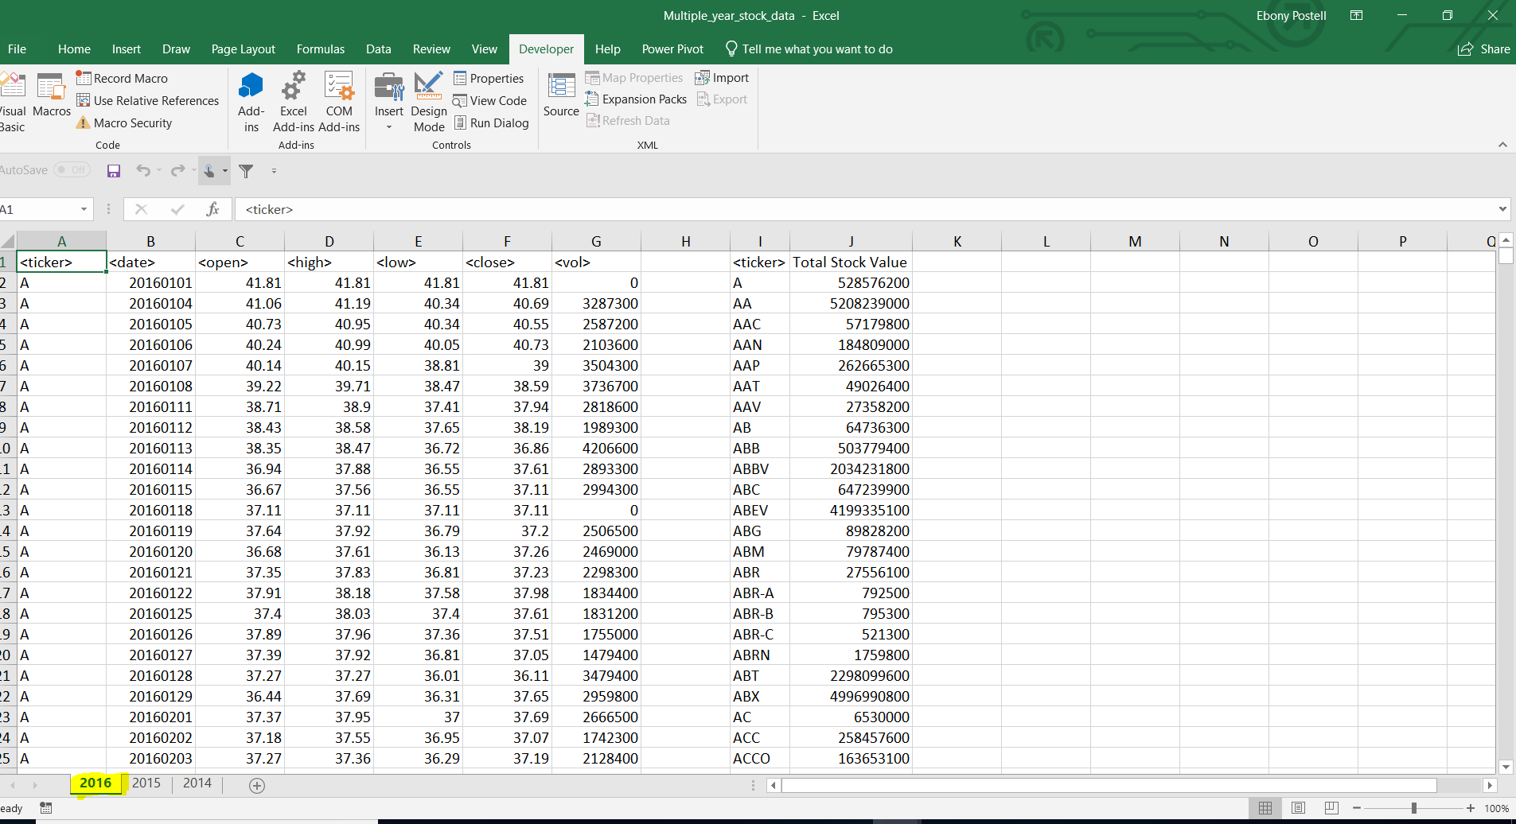

Figure 1: 2016 Output Results

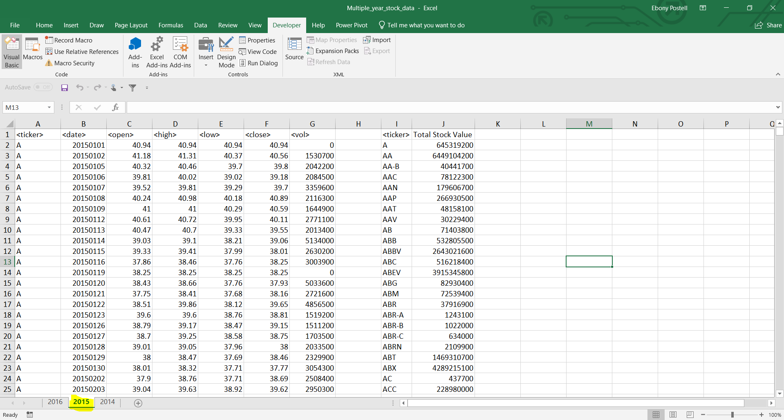

Figure 2: 2015 Output Results

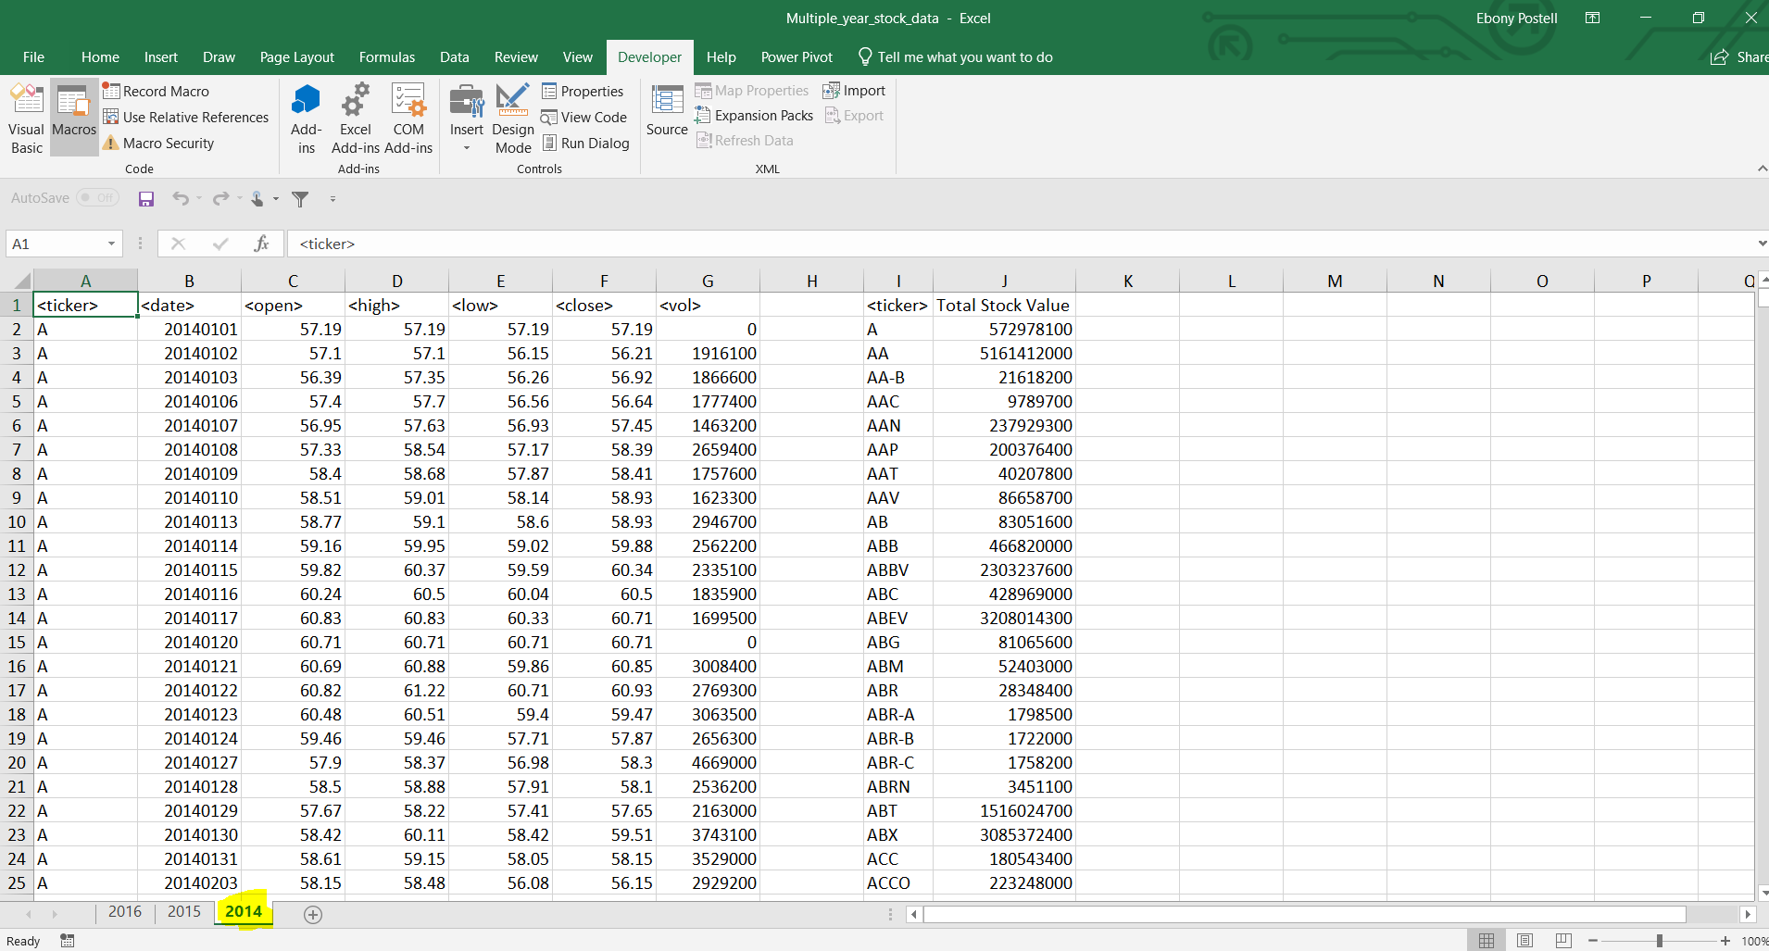

Figure 3: 2013 Output Results